**Addeur’s Requirement- Truck Booking App**

* **Design**

*The app is* ***combined/integrated*** *with both carrier and customer side, which the app is switchable either for the carrier or customer side. As we know, some of taxi booking companies part their service into two different apps. However, we only use* ***one****.*

*The overall design style of the app please follows these keywords:* ***minimalist*** *style, using more* ***pictures or images*** *instead of words, interface as* ***clean and simple*** *as possible but with* ***pleasant/beautiful/bright/eye-catching*** *colours. Our theme colours would be* ***deep blue, green, and white****. Additionally, the provided pictures showing in the contents are totally samples of our preference, you might design yours based on your will and skill if you are confident. We believe in you.*

**Section 1- app opening to using stage**

*In section 1, it introduces you to the app's first opening slash screen, preparation of ‘choice section’ before entering/showing the ‘Home Page’.*

1. The first page when every time opening the app is the slash screen as other apps do, which our logo is right in the **middle** of the screen. We prefer deep blue, white, or green as the background colour. The display-period of the slash screen please sets around 3 sec. Also please consider the sample showing as pic. 1.

 pic.1

1. The second page turns into the ‘**choice section’** that lets users choose either ‘I’m a carrier’ or ‘I’m customer’ locating in the middle of the screen, every of which uses a **cartoon image** for representing their identity. For example, this ‘I’m carrier’ specifically points truck driver, so please find out/design a descent/cute cartoon image for truck driver’s representative as well as for the customer. Check pic.2 and pic. 3.

 pic.2  pic.3

‘I'm a carrier.' ‘I’m customer’

*Please be aware that both two images are just layout and style for you considering. The real presence and images please find/design much more **pleasant and cohesive** ones.

1. Whether the user chooses ‘I’m carrier’ or ‘I’m customer’, the next page will always turn into the **‘Home Page’** which is the main function page.
2. If the user chose ‘I’m carrier’, it automatically goes to the carrier version. ‘I’m customer’ in turn goes to the customer version. (we will explain more about those two versions’ differences on the later content)

**Section 2- Debut of ‘Home Page’, ‘Order’ and ‘Information’**

*On the* ***lowest bottom****, there is a bar that has been equally divided into* ***3*** *buttons. The first button is the current main function page, showing the map, departure/destination details filling, etc, called '****Home Page****’. The second button is ‘****Orders****’. The third one is ‘****Information****’. Showing as pic. 4.*

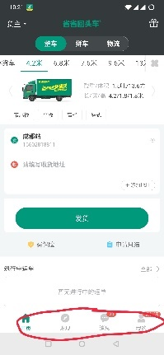 pic. 4

**‘Home Page’ Button**

*Now, it is the main function page or* ***‘Home Page’****. Please follow these keywords for your designing instruction, clean, clean, and clean! You can place the departure and destination filling bar on* ***top*** *or* ***bottom*** *of the screen depending on which is more looking cohesively and pleasantly. Check our preferable style on pic.5.*

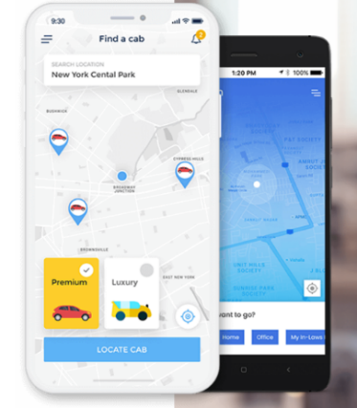 pic.5

1. Once the carrier or customer has completed the details filling for the place of departure and destination (*BE AWARE, customer and carrier are filling details differently. Customer- the place of departure and destination. Carrier- Arriving time estimation and Arriving place*), the page will automatically turn into ‘**registry**’ stage. **Firstly,** popping up a phone number registry-page requires the user to fill up his/her phone number, and **secondly,** clicks the ‘Get verification code’ button and fills that code. **Thirdly**, clicks the button of ‘Agree with our Agreement, Register and log on’. Check pic. 6 – pic. 8.

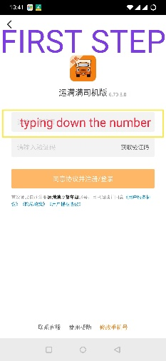pic. 6 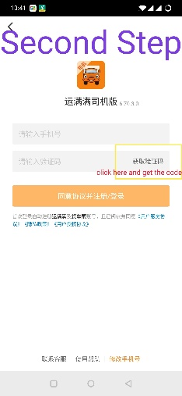pic. 7 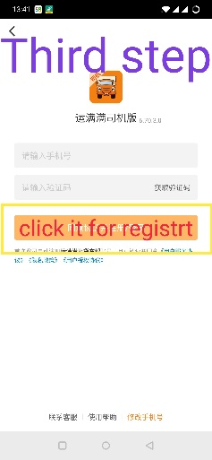pic. 8

1. After he/she completed the registry stage, and now it goes to the '**Verify**’ stage. The ‘carrier’ and ‘customer’ details filling are differently. For the customer (pic. 9), we require uploading his/her selfie through opening the phone's camera, filling upon the name and national identity number. For the carrier (pic. 10), we require uploading his/her selfie through opening the phone's camera, filling upon the name and national identity number. Also, fills upon his/her truck type (pic. 11). (we need 7 types of truck 1) ‘Cold-Chain’ 2)‘4.2 miters’ truck’, 3)‘6.8 miter’s truck’, 4)‘7.6 miter’s truck’, 5)‘9.6 miter’s truck’, 6)’13 miter’s truck’, 7)’17.5 miter’s truck’)

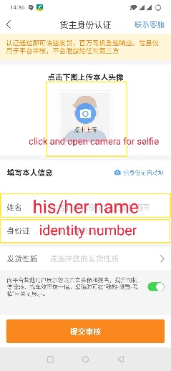pic. 9 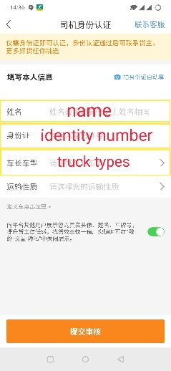pic. 10 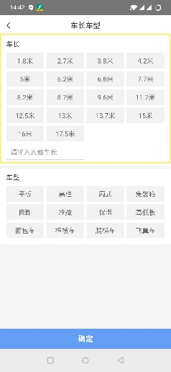pic. 11

1. Once the customer or carrier has completed the whole process of ‘Registry’ and ‘Verify’, our service officially begins for carrier and customer matching where should be a **small-size pop-up screen** for reminding the user that ‘Now we are striving for finding a proper carrier for you, the time will take from 1 sec to 24 hours. Please wait patiently.’ **This popp-up screen should last around 3 sec**. On the other hand, to who has already logged onto our app (old users), it just begins the matching and dispatching process.
2. On the **top left** of the display, there should be a switchable button which is for ‘carrier side’ or ‘customer side’ switching. Check pic. 12.

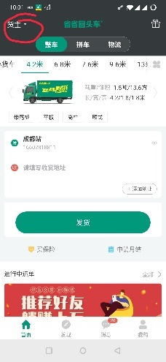 pic.12

**For the ‘Customer’ Version:**

* Check pic. 13, there are two types of taxi you can see, premium and luxury. But now, we need **7** types of truck, 1) ‘Cold-Chain’ 2)‘4.2 miters’ truck’, 3)‘6.8 miter’s truck’, 4)‘7.6 miter’s truck’, 5)‘9.6 miter’s truck’, 6)’13 miter’s truck’, 7)’17.5 miter’s truck’. You might completely consider or copy/paste the pic. 6’s designing style, scrolling the types of the truck from right to left for selecting those **7** different ones, respectively.

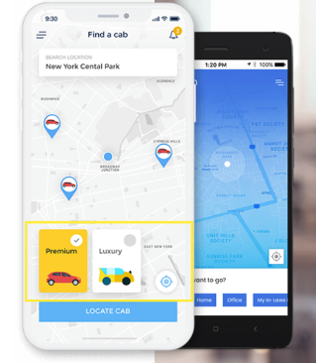 pic13.

* On the **top right** of the screen, there is a button for chatting that can be opened and checked the message between the user and his/her recipient. Check pic. 14.

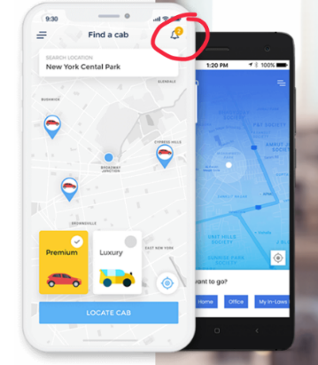 pic. 14

**For The ‘Carrier’ Version:**

* There is only one difference compared to the ‘customer side’. The details filling bar of ‘departure’ and ‘destination’ (see pic. 15) should be replaced to ‘**Arriving place**’ and ‘**Arriving time estimation’** fillings.

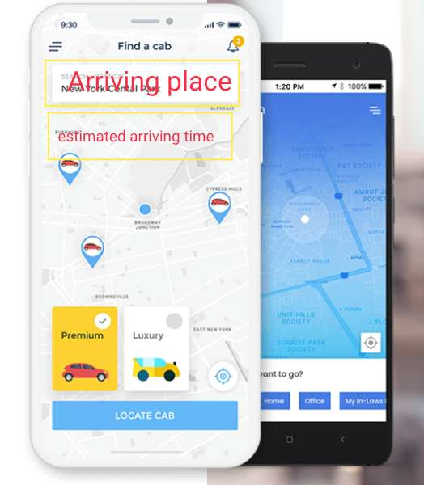 pic. 15

1. Following the chatting instruction on pic 14., when you clicked and opened the top right button, and the page should turn to a common chat page. Please keeps the page-design as simple as possible, but also pleasant. There should be a ‘voice sending’ function and ‘emoji sending function embedded. Check pic.16.

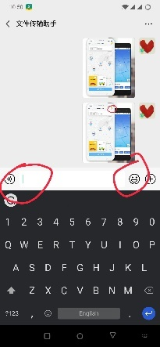 pic. 16

**‘Order’ Button**

*The top right chatting button remains the same. (pic. 7)*

1. Please looks back to pic. 4, the second button **‘Orders’.** When you click and open it up, it supposes to show the ‘**Ongoing order’** and ‘**Previous orders’**. Each order should be **framed** (pic yellow showed). The sort rankings of each order should be based on the time of its ordering history from the oldest one on the bottom to the newest one on top, respectively. Also, on the **frame** of the **ongoing order** customer is able to click and open through the ‘**tracking button’** for the truck’s **current location** tracking (pic. 17). Also, there is the second button on the frame for ‘**details’** checking, once you clicked and opened the **‘details’** button you are able to gather the order’s details, including a) the cost of the order, b) the truck/driver’s details such as the truck’s register number, brand, type, and driver's profile picture. (pic. 18). Thirdly, the button should be the **‘Get invoice’,** but the ‘Get invoice’ function should not be available (showing as blank font) until the order has completed. The button should be there but no functions at all at this stage.

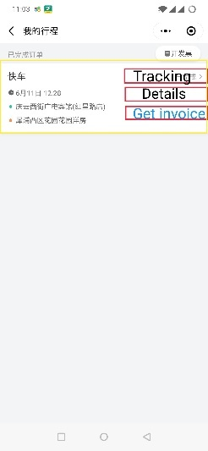pic. 17 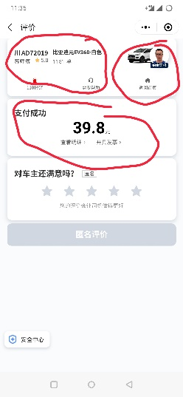 pic. 18

On the other hand, on the frame for the **previous orders,** there are only **2** buttons available one of which is the ‘Details’, another is the ‘Get invoice’ (pic. 19). The 'Tracking' function here is **no longer** showed and available. In turn, the ‘Get invoice’ is **now** available/clickable, and turning to show as the regular font. User can click the ‘Detail’ button to check about their previous order’s details, including a) the completed cost of the order, b) the truck/driver's details such as the truck's register number, brand, type, and driver's profile picture, and **c)** reviewing the truck’s service (This is an extra compared the ‘Current ongoing order’). (pic. 20)

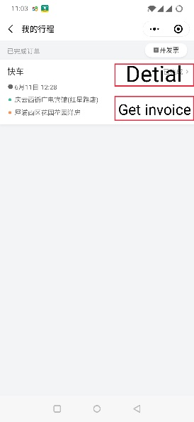 pic. 19 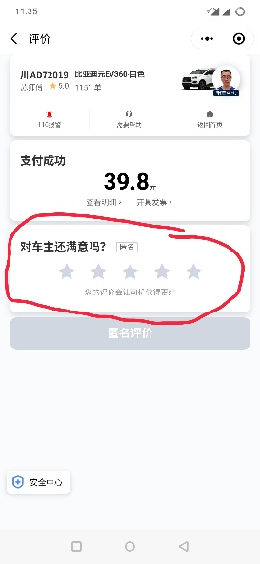 pic.20

**‘Information’ Button**

*Now, it goes to the third****-lowest button 'Information'.*** *On the* ***top right*** *remains the same for that* ***chatting*** *button (pic. 7). Be aware, the following provided pictures are just samples for your better understanding. The layout is totally changeable with your design and will. Do not forget the app's principle,* ***minimalist*** *style, using more* ***pictures or images*** *instead of words, interface as* ***clean and simple*** *as possible but with* ***pleasant/beautiful/bright/eye-catching*** *colours.*

1. Pic. 21 shows the register function for users who didn’t get through or missed the first registry and verify. He/She can manually click and start the ‘registry’ and ‘verify’ process. Please relook the bullet point 5-6, and the pages are wholly the same.

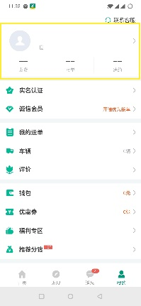pic. 21

1. Pic. 22, an independent button for the ‘Verify’ process is designed for whom has already registered but has not verified, please relook bullet point 6 for the entire pages.

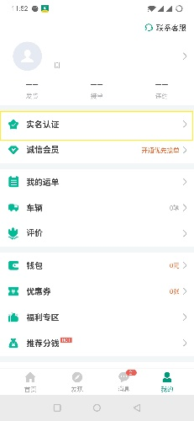 pic. 22

1. For this function bar, it is **only** showing in the carrier’s version, which is **‘Manage My Truck’**.(pic. 23) After clicked and opened **‘Manage My Truck**’, there are two options one of which is **‘Manage my current Truck’**, and **‘Add New Truck’**. (pic. 24)

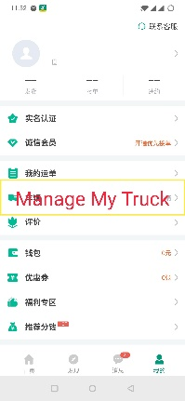 pic. 23 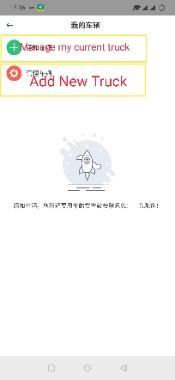 pic. 24

1. Pic. 25 would be the ‘Coupon’ function, please follow your template and design making this bar for us.

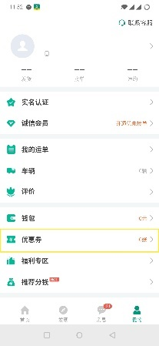 pic. 25

1. Pic.26 is the **‘My wallet’** button. Go inside of ‘My Wallet’, users are able to manage their payment/withdrawal method. For the carrier version, it is for checking their current balance and withdrawing their balance to Alipay and Wechat Pay, but the customer version is for checking their bill and charging credits into the app’s wallet. Of course, customers can also pay directly via the third party such as the 3 widely-used methods in China, **1) China Alipay, 2) Wechat Pay 3) Credit Card**, without credits adding. Please google.com or baidu.com their open-source code in order to embed to here.

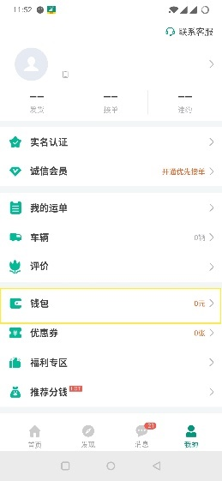Pic. 26

1. Pic. 27 is the ‘User Guide’ button, please vacant this place. We will fill this part by ourselves.

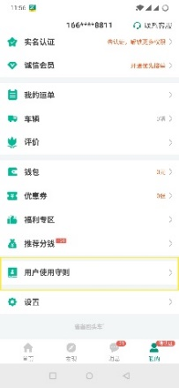 pic. 27

1. The last button in **‘Information’** is the **setting**, including user’s profile **image setting**, **account safety** (for customer version is payment password setting/changing, but for carrier version is withdrawal password setting/changing), **help centre** (out contact phone number, ticket submission, chat bot- bot reply and human reply), the **current app’s version number display**, and **about us**. (pic. 28)

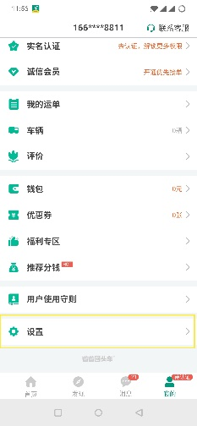pic. 28

* **Features**
* Automated dispatching system (the mapping system can only use China’s Gaode Map, <https://lbs.amap.com/> This is the open-source platform)
* Schedule booking for later trips
* Carrier version and customer version are combined into one app, but it is switchable
* Voice and pop-up screen for carrier version for the possible orders
* Intelligent calculation system. For example, there is a city B, a driver is currently in city C and wants to return to city A. While the city B is somewhere near the way back from C to A. So, the system can set a 35-kilometer’s radius or whatever range according to the mapping system calculated route, from the departure place to destination place, and give driver’s pop-up page and voice suggestion

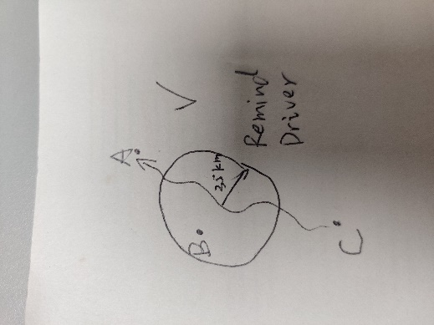 YES! 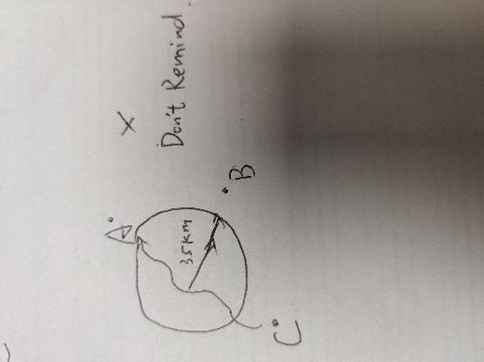 NO!

* Passenger should be able to pay through credit card, Chinese Alipay and Wechat Pay Payment gateway integration Online payment & e-receipts after the service is delivered
* Both driver and passenger can manage booking history
* Passenger can track the driver's current location
* Hire trucks & hire driver module on user application
* Easy navigation and tracking system
* View ongoing trips in real-time
* Credit/Wallet system for user & drivers
* Total Commission calculation, driver earning on individual lead
* Live Status of assigned driver, assigned trucks, unassigned trucks & drivers, live passengers